Alyana Barrera’s Individual Portfolio

By Alyana Barrera

December 8, 2022

Major: Computer Science

EGR 3350-07 | Technical Communications for Engineers and Computer Scientists

Ms. Alysoun Taylor-Hall | Individual Portfolio

**Table of Contents**

1. **Mechanism Description 2**

Revision Plan 2

Revised Report 3

Original Graded Assignment

1. **Process Description**

Reflection

Original Graded Assignment

1. **Recommendation Report**

Reflection

Original Graded Assignment

1. **Group Project (Group 3)**

Reflection

Letter of Intent (LOI)

Annotated Bibliography

Proposal

**Mechanism Description: Revision Plan**

* Be detailed but concise

One of the problems of the assignment I turned in for the mechanism description was the length of the paper. The paper was too long for the requirements of 2 pages. A suggestion from my graded assignment is to re-evaluate the parts I am describing and to shorten the explanation of the housing.

* Re-evaluate the parts I will be describing

I will try to look into adding the buttons as a whole section and try to shorten the other sections by being descriptive.

* Fix grammar errors

I am going to look through the entirety of the paper and work on grammar errors. This will make the paper cohesive and blend together

Targus Computer Mouse

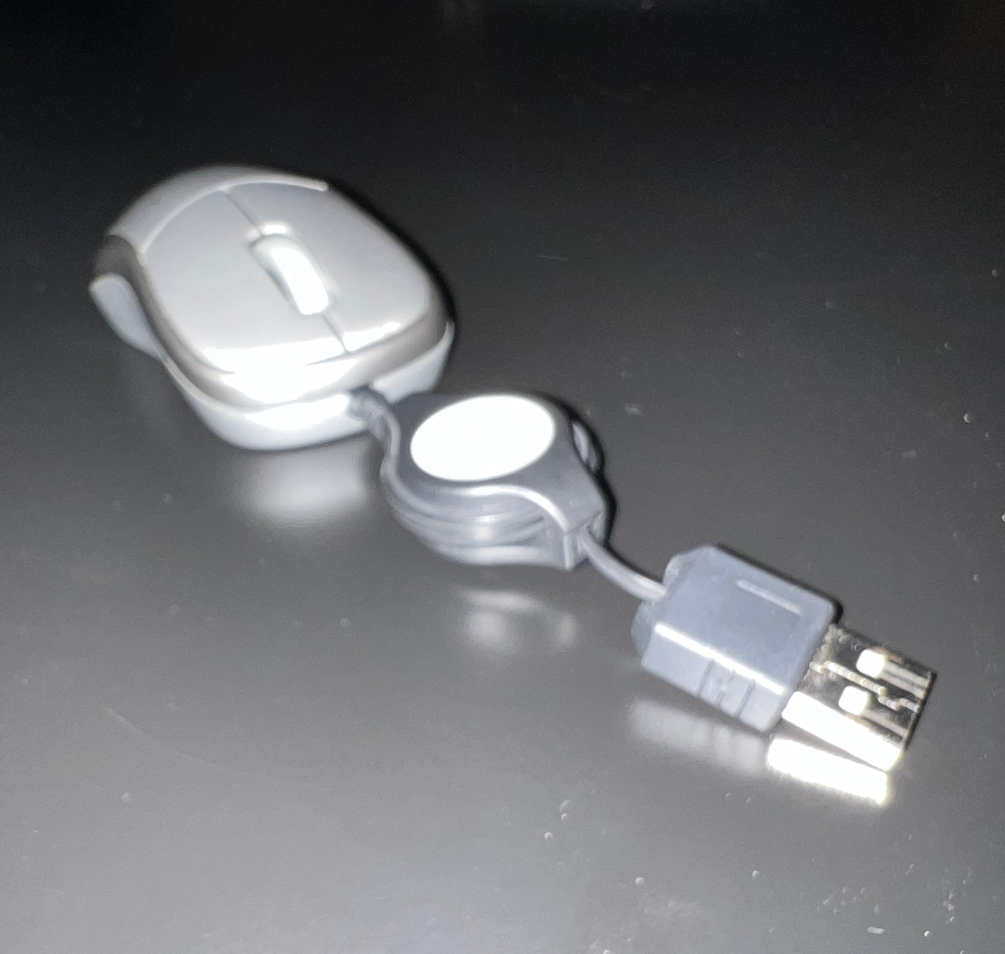

Figure 1: A Targus Mouse

Source: Author

By Alyana Barrera

September 13, 2022

Major: Computer Science

EGR 3350-07 | Technical Communications for Engineers and Computer Scientist

Ms. Alysoun Taylor-Hall | Mechanism Description

Introduction

A *Targus computer mouse* is a handheld device helping computer users select certain points on a computer screen through being dragged on a flat surface. When used the mouse has a sensor underneath to reflect the the user’s movement onscreen. It has a black retractable extension cord to allow for a bigger range of motion. It is plastic and bean shaped with an extension cord that comes out of the top and rolls into a circular ring with a USB port at the end. It is approximately 10 mm tall, 20 mm wide, and 35 mm long. The mouse has four main parts: the base, palm-rest, sensor, and wheel.

Discussion

Refer to Figure 2 for an image of the mouse with its parts.

Base

The *base* is bean-shaped that holds all parts of mouse and is the main contact for the flat surface when dragged by the user. The bottom has an opening for the nail attachment. The inner walls contain four thin, chair-like supports acting as a seat for the sensor. The center has a clear plastic rectangle for the sensor and two vertical 10 mm tall plastic pieces to hold the wheel. At the top, a semi-circle opening in the wall holds the extension cord and two 1 mm horizontal rectangle pieces of plastic that holds the palm-rest when attached.

Palm-rest

The *palm-rest* is the top cover for the device acting as the rest for the user’s palm. It holds three individual curved rectangular plates surrounded by a 3 mm edge plate. At the bottom is a square plate with rounded edges for the user to rest their palm. Right and left clicker buttons allow the user to click items on the screen. The long sides of the right and left buttons have a vertical oval shaped opening where the wheel can peek out.

Wheel

The *wheel* is a tire-shaped piece of rubber used to allow scrolling on the screen. It has a light grey rubber ring with a 2 mm black filler plastic piece. At the center of the black filler piece is a 3 mm black cylindrical piece on both sides of wheel to allow the wheel to sit on the base’s vertical holders. The sensor would go right underneath.

Sensor

The *sensor* allows the mouse to work through sensing movement from the base. It is “A” shaped and flat. The top half is gold and the underside is green. On gold side, at the top of the “A”, there is a black box with a 2 mm length, width, and height. To the left side of the “A”, there are three cylindrical batteries that are 3 mm in height and 1 mm in diameter.

Conclusion

A *Targus computer mouse* is a handheld device that helps computer users select certain points on a computer screen through being dragged on a flat surface. The mouse is composed of five parts: the base, which serves as the plate that holds all parts; palm-rest, which supports theuser’s palm and allows for clicking and the use of the wheel; sensor, which detects the movement of the flat surface; andwheel, which allows the use of scrolling in a browser. A computer mouse is helpful to all computer scientists and engineers when working with computers.

Wheel

Palm-rest

Base

Extension cord

Sensor

Figure 2: A Targus computer mouse and it’s labeled parts

Source: Author

Process Description Reflection

For the process description assignment, I liked how it made me think about how to explain processes. The process I explained was web development and how to make a simple website. What challenged me was the fact of trying to figure out what to explain because web development is super broad.

Recommendation Report Reflection

Group Project Reflection (Group 3)

**Mobile Application for Electronic Medical Records**

EGR 3350-07: Technical Communications for Engineers and Computer Scientists

Ms. Alysoun Taylor-Hall

Proposal

December 1, 2020

Dougie ****

Computer Science Engineering Student

Alyana Barrera

Computer Science Student

Joy ****

Computer Science Engineering Student

Samuel ****

Electrical & Computer Engineering Technology Student

Kha ****

Computer Science Student

**Abstract**

The medical field today is riddled with old technology and paper records that are too difficult to search through. This makes it harder for patient data records to be sent and retrieved from hospital to hospital. The lack of standardization between the various hospital information systems exists as a problem. The following proposed solution will eliminate the issue of retrieving patient records from within a hospital and other hospitals. A health informatic mobile application will allow clinicians to pull and update digital records with ease. Underserved patients report high rates of [cell phone use](https://www-sciencedirect-com.ezproxy.libraries.wright.edu/topics/medicine-and-dentistry/cell-phone-use) and interest in using mobile technology for health care [1]. Medical applications make mobile devices a useful tool in the practice of evidence-based medicine at the point of care and in addition to their use in clinical communication. Hence, mobile devices can play a very important role in patient education, disease self-management, and remote monitoring of patients [2]. A bi-directional integration of a mobile healthcare communication system, between patient and provider, may improve access to health care management.

[1] Moore, S. L., Fischer, H. H., Steele, A. W., Joshua Durfee, M., Ginosar, D., Rice-Peterson, C., Berschling, J. D., & Davidson, A. J. (2014). A mobile health infrastructure to support underserved patients with chronic disease. *Healthcare*, *2*(1), 63–68. <https://doi.org/10.1016/j.hjdsi.2013.12.016>

[2] Mosa, A. S., Yoo, I., & Sheets, L. (2012). A systematic review of healthcare applications for

smartphones. *BMC Medical Informatics and Decision Making*, *12*(1). <https://doi.org/10.1186/1472-6947-12-67>

**Research Plan**

Introduction

Purpose

The purpose of this report is to propose a downloadable app for mobile devices and computers that will serve as a platform to store and update patient records between clinics, clinicians, and patients.

Background

The medical field is riddled with paper records of patient data that are space-consuming and difficult to retrieve. The main problem of information systems and communication between hospitals and patients is the lack of standardization [1]. The pandemic pushed for a digital transformation since patients were not able to be in person for medical treatments. Hospitals had to adapt their information systems to deliver the best experience for their patients' needs.

Under the consent of many provider networks, this proposal addresses a particular software that can be developed to obtain patient information from their records system allowing patients and clinicians to view, utilize, and understand their hospital history on a mobile app screen for treatment [2]. Medical applications make mobile devices useful tools in the practice of evidence-based medicine at the point of care, in addition to their use in mobile clinical communication. Underserved patients report high rates of [cell phone use](https://www-sciencedirect-com.ezproxy.libraries.wright.edu/topics/medicine-and-dentistry/cell-phone-use) and interest in using mobile technology for health care [3]. Hence, mobile devices can play a very important role in patient education, disease self-management, and remote monitoring of patients [4]. A bi-directional integration of a mobile healthcare communication system, between patient and provider, will improve access to health care management. This app will have 2 types of users for the login process: patients and clinicians. Logging in as patients will provide them with an ease of access and app functionality for self-monitoring. Logging in as clinicians will allow clinicians to check on patient history and care plans and will also allow communication with patients to discuss events and treatments.

Scope

This project will provide development research of a medical software application for mobile devices, and initial testing. The product will not yet be ready to launch worldwide.

Discussion

Approach

The app will consist of 4 major components: front-end, which is the user interface; back-end, which includes a database and storage; API; and cybersecurity.

The mobile app interface implementation is designed with two perspectives. The patient mobile app, which is equipped with a QR (Quick Response) code, simulates a ‘key’ to unlock patient intake information required by the hospital/clinicians which includes insurance information, medical history, vaccinations, and other details pertaining to the visit. The patient app provides accessibility to appointment scheduling, direct communication via chat or direct phone call, prescription notification, and other features. The clinician/hospital mobile interface enables immediate access to task management, notifications, and scheduling. This interface provides prescription tracking, billing, invoicing, and claims management.

The application will be retrieving and storing patient records so there will be a need for a database to manage the large amounts of data. A patient's medical history, vaccination, and personal information are recorded in electronic medical records(EMRs). The implemented database for the application will be able to hold large amounts of EMRs from all participating medical institutions [5]. When requesting, storing, or updating a patient's medical information, the mobile application will access the requested patient's EMR through the database. The design of the database is an important portion of the database management. The relational schema and design can be created with the popular database management system MySQL. The logical structure for the database will be best created with a series of SQL statements which formulates a data model [6]. With the application needing a database to manage EMRS, the data will need to be stored in a server.

This application will use cloud based storage for the medical records of patients. Working with a cloud-based system will allow for cheaper operating cost and raised efficiency. A cloud-based system cuts information technology costs by greater than 20% and allows for flexibility in storing information [7]. This is helpful for mass amounts data that will be collected by hospitals for the app. When compared to a web-based database management system, a cloud system is 20% faster when processing user requested services and queue wait time is 3.8% less when processing a heavier workload [8]. Data retrieval time for a file size of 1 KB can be as fast as 5 milliseconds [9]. This will help during operational hours for the hospitals to be able to search and insert patient data quickly. The cloud computing application type that will be used is SaaS or software as service. SaaS will allow for personalization services for user-oriented system configuration [8]. Although cloud-based storage is useful for cheaper operational costs and efficiency, security measures do need to be placed for protected patient information.

The API or Application Programming Interface will be needed for all functions of the app. API acts as a mediator which provides connection between the front-end and back-end within the app, also communication between a software and another software. Similar to the app, API is also made of code. Depending on the purpose of each function within the app, API will be coded differently. Multiple APIs can be used within one single app. APIs can be self-created, or there are many existing APIs which are available for public use or purchased from vendors, so it doesn’t have to be created from scratch again. However, for the purpose of budget saving in this project, APIs will be self-created by the group members. RapidAPI is known to be the world’s largest API marketplace where millions of developers have been up to [10]. Therefore, the tool which is used to create APIs in this project will be Paw, part of RapidAPI’s platform. Paw has been the number one choice among developers for the last five years by providing a fully-featured support to build any API requests [10].

Since the app will be handling sensitive data. We will be referring to the regulations outlined in Health Insurance Portability and Accountability Act (HIPAA) and Health Information Technology for Economic and Clinical Health (HITECH) [11]. We will create a data tag so we can distinguish sensitive information from other non-sensitive information within the app. Also, tagged incoming data from other software applications so we can decipher that information as well. The best approach to this method would be to tag data on the device based on the sensitivity level of the source repository from which the information comes from. The app will generate a list of trusted private repositories which contain sensitive information. The private repository will be encrypted to ensure the security of the data. The tagged data can be stored on the file system, users will have the permission to accept or deny the storage request by the app. Data input by the user into the app could also be sensitive. Our app will provide two modes of data entry into the app. A secure data entry point will be provided in the app to handle the sensitive data ensuring the information will be properly identified and tagged

Result

This project will result in a completely developed mobile app that can be installed on mobile devices for the purpose of health informatics. Along with additional research and testing, this app will ensure its function to optimize the interactions between clinics and patients, and the use of patients data at these clinics. The innovation of the app will significantly decrease the average wait time or the overall time it takes for a patient to be taken care of. The app will promote patient education, disease self-management, and remote, bidirectional integration of a mobile healthcare communication system, between patient and provider, improving access to health care management.

Statement of Work

1. Background Research (1 months)
2. Front-end Development (2 months)
3. Back-end Development (2 months)
4. Cybersecurity Development (2 months)
5. Front-end/ Back-end/ APIs/ Security Integration (2 months)
6. App Testing (3 months)

Deliverables/Timeline

The project will start 1 month after the RFP due date.

Conclusion

Summary

The medical field is riddled with paper records that hold patients’ medical data which is space-consuming and difficult to retrieve as the hospital grows. The recent pandemic helped push for a digital transformation since patients were not able to be in person for medical treatments. However, there still remains a lack of standardization between information systems which makes it more difficult for a clinic to send patients’ records to other clinics [1]. As for a solution to this problem, an online software application that can be installed on every mobile device has been proposed. This mobile application will significantly enhance medical treatment processes and optimize the use of patient’s data records. After one year from this project’s start date, an online software application for health informatics will be installed and widely used in the medical field across the country.

**Alyana Barrera**

(937)-999-9999 | Email: barrera.13@wright.edu

**EDUCATION**

Bachelor of Arts in Computer Science Expected, May 2023

Wright State University, Dayton Ohio

* Certificate in Cybersecurity
* Minor in Business

**RELEVANT COURSEWORK**

* Computer Science
* Computer Organization
* Cyber Security
* Web Development
* Information Technology Systems
* PC Networking
* Oracle/SQL Database
* Operating Systems

**TECHNICAL SKILLS**

* Programming Language: Assembly, C++, C, Java, JavaScript, PHP
* Operating Systems: Proficient Mac OS X, Basic Knowledge in Windows
* Software Applications: Microsoft Office Products, Visual Studio, Brackets, VMware, Xcode, VirtualBox, Orange, Ubuntu, Git

**WORK HISTORY**

Lane Avenue Chiropractic – Columbus, Ohio 11/26/22 – Current

Chiropractic Assistant

* Assist doctors with new patients and consults for x-rays.
* Verify insurance and payments.
* Set schedules for patient care plans set by the doctors.

Funk Lab Dance Center – Kettering, Ohio 08/07/18 – 06/06/22

Studio Administration

* Answer and help resolve customer/parent questions.
* Handle payments for tuition and other fees from customer to studio.
* Record notes of what happened in Studio to provide to the Business Owner.

**RELEVANT PROJECTS**

* Built a GUI matching game using **Java**.
* Created a character game using **C++**.
* Performed ER design, DDL, design, and DML development/testing using **SQL**.
* Designed websites with **HTML**, **CSS**, and **JavaScript**.
* Connected websites to databases using **PHP**.

**Facilities and Equipment**

For this project, in-person group meetings will take place in a rented office facility. Extra devices and hardwares will be needed for later testing. All development work will be conducted on personal laptops or computers.

**Budget and Justification/Costs**

|  |  |  |  |  |
| --- | --- | --- | --- | --- |
| **Category** | **Item** | **Number** | **Subtotal** | **Total** |
| Personal | Salary  (5 employees) | 2000  hours | $40/hour | $80,000 |
| Equipment | Hardware | Server(1)  iPads, Tablets [13] | $67,000 [13] | $67,000 |
| Facilities | Office Building  (1873 ft²) [12] | 1 Room | $18.00/ft²  /year [12] | $33,714 |
| Supplies | Other | Wiring, Surge Protectors [13] | $12,000 [13] | $12,000 |
| **Final Cost:** | | | | $192,714 |

**Figure 2:** Mobile App Projected Costs

Source: Authors

Part of our budget includes renting out an office building for our research, testing, and implementation of the mobile application. The office building we have looked into is located in Fairborn, Ohio where it has 1873ft² of land at $18 per ft² [12]. From our calculations, this building will be a total of $33,714 for the year. For the remainder of the budget we will have wages for full-time staff, hardware expenses, and other supplies. Staff will have a pay rate of $40 an hour working 2,000 hours equating to a total of $80,000 for the year. The hardware expenses will include a database server, iPads, and tablets with a total of $67,000 [13]. The other supplies that we will be investing our budget into are wiring and surge protector supplies with a total of $12,000 [13]. Our final cost for the year-long proposal is $192, 714.

**Contact**

For more information regarding this proposal, please contact

* Dougie Townsel at [townsell.4@wright.edu](mailto:townsell.4@wright.edu)
* Alyana Barrera at [barrera.13@wright.edu](mailto:barrera.13@wright.edu)
* Kha Le at [le.55@wright.edu](mailto:le.55@wright.edu)
* Samuel Medley at [medley.17@wright.edu](mailto:medley.17@wright.edu)
* Joy Fisherback at [fisherback.3@wright.edu](mailto:fisherback.3@wright.edu)

Sources

[1] Bandur, A., Binsar, F., Kartono, R., & Kosasih, W. (2022). Digital Transformation of Information Fulfillment and Patient Engagement for Health Service Safety. *Association for Computing Machinery*, 229–236.

<https://dl-acm-org.ezproxy.libraries.wright.edu/doi/10.1145/3535782.3535813>

[2] Bidargaddi, N., van Kasteren, Y., Musiat, P., & Kidd, M. (2018). Developing a Third-Party Analytics Application Using Australia’s National Personal Health Records System: Case Study. *JMIR Medical Informatics*, 6(2), e28.

<https://doi.org/10.2196/medinform.7710>.

[3] Moore, S. L., Fischer, H. H., Steele, A. W., Joshua Durfee, M., Ginosar, D., Rice-Peterson, C., Berschling, J. D., & Davidson, A. J. (2014). A mobile health infrastructure to support underserved patients with chronic disease. *Healthcare*, *2*(1), 63–68. <https://doi.org/10.1016/j.hjdsi.2013.12.016>

[4] Mosa, A. S., Yoo, I., & Sheets, L. (2012). A systematic review of healthcare applications for

smartphones. *BMC Medical Informatics and Decision Making*, *12*(1). <https://doi.org/10.1186/1472-6947-12-67>

[5] Hirose, N., Tsujimoto, N., Katayose, T., & Chin, R. (2021). Utilization of glucagon‐like peptide‐1 receptor agonists and changes in clinical characteristics in patients with type

2 diabetes by chronic kidney disease stage in Japan: A descriptive observational study using a nationwide electronic medical records database. *Diabetes, Obesity and Metabolism*, *24*(3), 486–498.

<https://doi.org/10.1111/dom.14600>

[6] Letkowski, J. (2015). Doing database design with MySQL. *Journal of Technology Research*, *6*, 1. <https://www.researchgate.net/profile/Jerzy-Letkowski/publication/271910489_Doing_database_design_with_MySQL/links/54dd41bf0cf282895a3b5175/Doing-database-design-with-MySQL.pdf>

[7] Jai-Woo Oh, Jin-Kyu Kang, & Jae-Young Park. (2019). A Study of Smart Healthcare Service

Model Based on Cloud Platform: Focus on small and Medium sized Hospitals.

*Medico-Legal Update*, *19*(2), 434–440. <https://doi.org/10.5958/0974-1283.2019.00216.0>

[8] Nayibova, M. (2017). The high price to pay for the cloud: how cloud based storage

applications streamline data storage, but pose legal issues and security risks to

private sector employers and employees alike. Baku State University Law Review, 3(2),

131-164.

[9] Challa, M., Bhatt, S. C., N., Usha, & R. K., Vidhur. (2022). Ensuring Privacy of Medical

Data in Cloudlet-Based Storage System. *Special Education*, 1(43), 4002-4007. <https://content.ebscohost.com/ContentServer.asp?T=P&P=AN&K=159789990&S=R&D=ehh&EbscoContent=dGJyMNLe80SeprE4zOX0OLCmsEqep7RSs6e4S7aWxWXS&ContentCustomer=dGJyMPGuskiurK9JucPfgeyx4I3x>

[10] Rapidapi Acquires Leading Api Design Solution Paw. (2021). *GUI Program News*, *32*(3), N.PAG. <https://eds-s-ebscohost-com.ezproxy.libraries.wright.edu/eds/detail/detail?vid=10&sid=4399be3f-ea6d-4b9f-ae98-893aad0e3360%40redis&bdata=JnNpdGU9ZWRzLWxpdmU%3d#AN=149069843&db=edb>

[11] Mustaque, et al. “*P*rotecting health information on mobile devices,” *Proceedings of the*

*second ACM conference on Data and Application Security and Privacy* February 2012,

pp 229–240. <https://dl-acm-org.ezproxy.libraries.wright.edu/doi/10.1145/2133601.2133629>

[12] Commercial Cafe. *Fairborn, OH Office Space for Lease or Rent | 10 Listings*. (n.d.). Www.commercialcafe.com. Retrieved November 29, 2022, from [Fairborn, OH Office Space for Lease or Rent | 10 Listings (commercialcafe.com)](https://www.commercialcafe.com/office/us/oh/fairborn/#:~:text=How%20much%20does%20office%20space%20cost%20in%20Fairborn%2C,as%20well%20as%20public%20transport%2C%20airports%20and%20highways.)

[13] Smith, P. D. (2003). Implementing an EMR System: One Clinic’s Experience. *Family Practice Management*, *10*(5), 37–42. <https://www.aafp.org/pubs/fpm/issues/2003/0500/p37.html#fpm20030500p37-bt2>